**DHCP option sets**

1.Create vpc_a in Mumbai region

2. Create dhcp

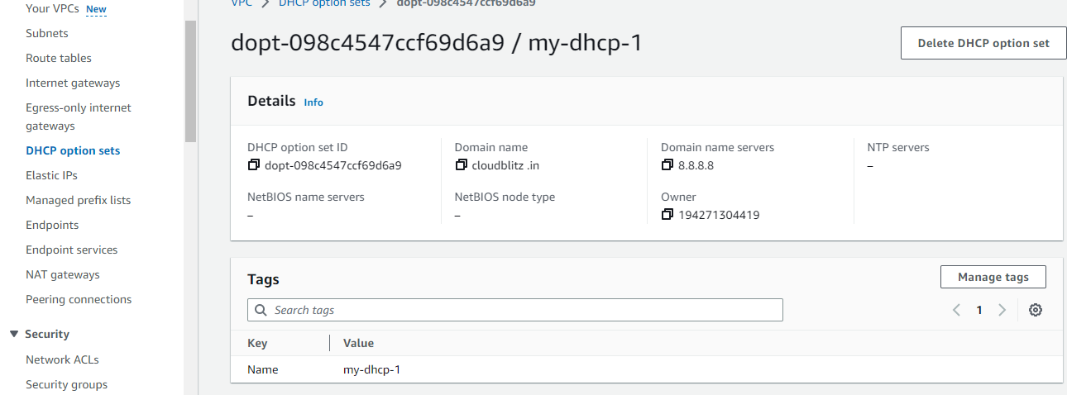

3. Attach dhcp to vpc_a:-

Go to action

Select vpc settings

Selct DHCP you have created

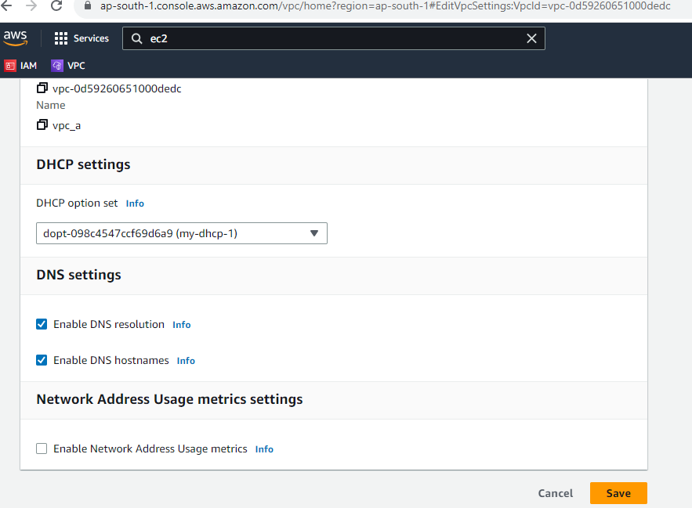

1. Now create instance with the vpc_a
2. and launch instance
3. type command hostname

